Name: ________________________ Date: _________________
Right Triangle Proportions Classwork Ditto

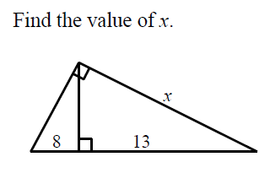

- In the diagram below, the length of the legs and of right triangle ABC are 6 cm and 8 cm, respectively. Altitude is drawn to the hypotenuse of .

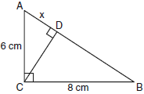

What is the length of to the nearest tenth of a centimeter?

- The drawing for a right triangular roof truss, represented by , is shown in the accompanying diagram. If is a right angle, altitude meters, and is 6 meters longer than , find the length of base in meters.

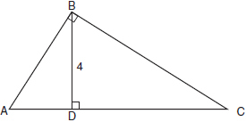

- In right triangle ABC shown in the diagram below, altitude is drawn to hypotenuse , , and .

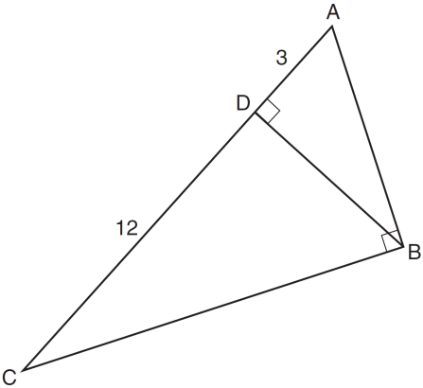

What is the length of ?

- In the diagram below of right triangle ABC, is the altitude to hypotenuse , , and .

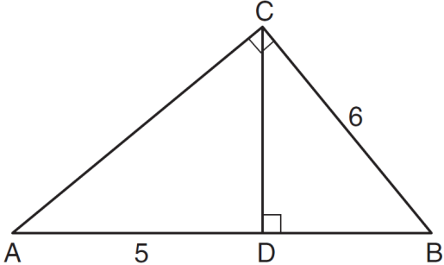

What is the length of ?

- In the diagram below of right triangle ABC, altitude is drawn to hypotenuse .

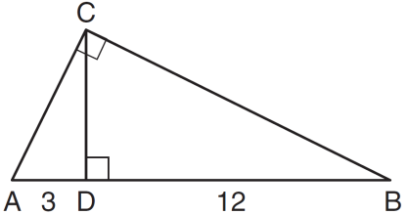

If and , what is the length of altitude ?

- In right triangle ABC below, is the altitude to hypotenuse . If and the ratio of AD to AB is 1:5, determine and state the length of . [Only an algebraic solution can receive full credit.]

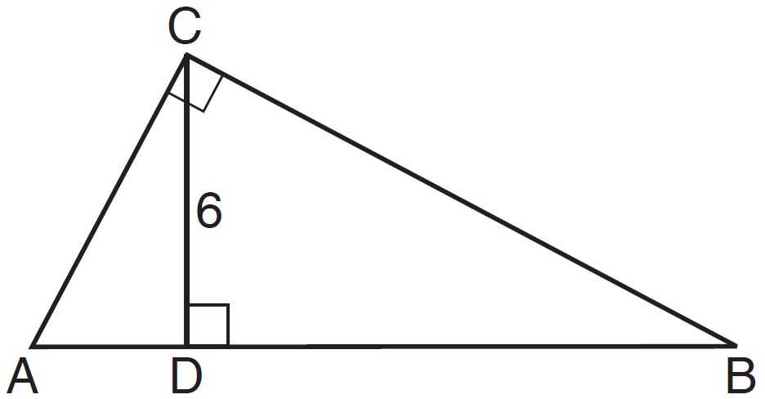

- In the diagram below of right triangle ABC, altitude is drawn to hypotenuse , , and .

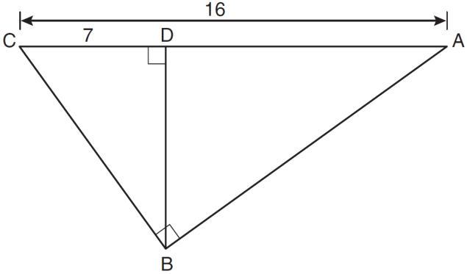

What is the length of ?

- Triangle ABC shown below is a right triangle with altitude drawn to the hypotenuse .

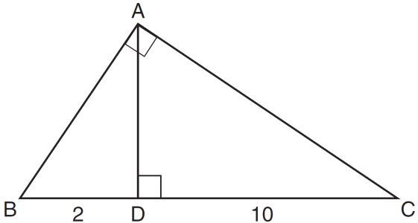

If and , what is the length of ?

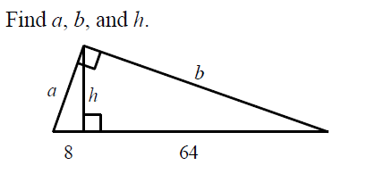

- In , is a right angle and is drawn perpendicular to hypotenuse . If , , and , what is the length of ?

- In the diagram below of right triangle ACB, altitude intersects at D. If and , find the length of in simplest radical form.

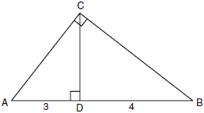

- In the diagram below of right triangle ABC, an altitude is drawn to the hypotenuse .

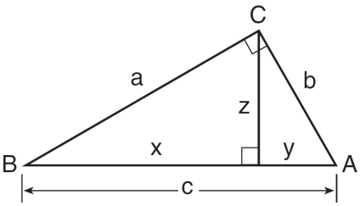

Which proportion would always represent a correct relationship of the segments?
1) | 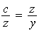
2) | 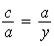
3) | 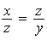
4) | 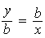

14.
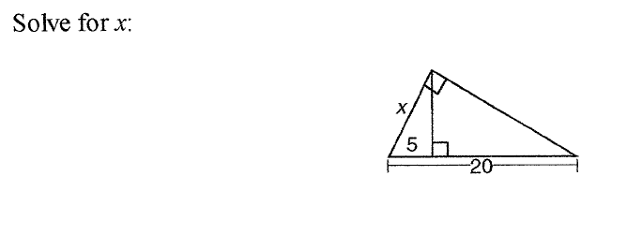

15.
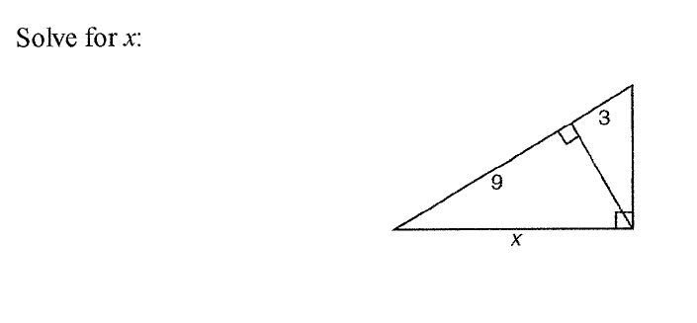

16.
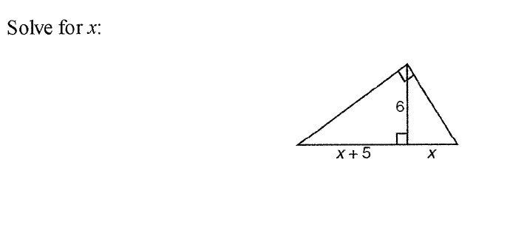

17.

18. 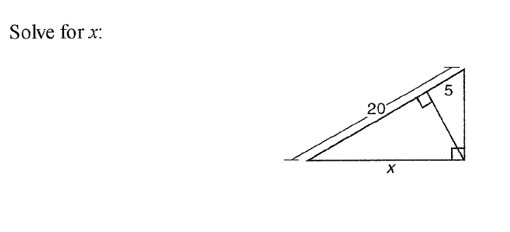

19.
In the diagram below, is a right triangle. The altitude, h, to the hypotenuse has been drawn. Determine the length of h.

